Thai Medical Desk — Improvement Plan

In short
The current system works well for tracking patients and billing, but it is only a demo: it runs in one browser and has no real login or shared data. To go live it needs a secure backend, plus three things a medical-visa business runs on: a hospital list, a visa tracker and an agent network.

Problems and gaps in the current system
Problem | What it causes
No real login or password | Anyone with the file can get in
Data saved only in one browser | Dhaka and Bangkok staff cannot see each other's work
Uploaded files disappear on refresh | Medical reports and passports are lost
Permissions can be bypassed | Staff can see or change things they should not
Hospitals typed by hand in each case | No price lists, no comparison, no partner contacts
No visa tracking | Missing documents found late; visa delays
No agent records | Cannot see who sent a patient or pay commission correctly
Patients cannot see their status | Repeated calls and WhatsApp messages to staff
No message templates or reminders | Slow, inconsistent replies
No business reports | Management cannot see conversion, revenue or profit by hospital or agent

What should be added
New features
Add | What it does
Hospital directory | List of partner hospitals and doctors with specialties, package prices and contacts; send reports to several hospitals and compare their quotes
Medical visa desk | Checklist of visa documents for patient and attendants, visa status, and reminders before the appointment date
Agent network | Record which agent sent each patient, calculate commission automatically, optional agent login to see only their own referrals
Patient portal | Patients log in by phone OTP to upload reports and see their stage, visa status, invoices and receipts
Online inquiry form | Website and Facebook inquiries create a new case automatically
Messages and reminders | Ready WhatsApp and email templates in Bangla and English, saved to the case
Business reports | Monthly inquiries, conversion, revenue and profit by hospital, agent and staff
Fixes to what already exists
- Add a "Visa" stage and a "Lost lead" status with a reason.
- Record the source of every patient (agent, Facebook, website, walk-in).
- Warn about duplicate patients by phone or passport.
- Online payment link (bKash, Nagad, card) on invoices.
- Export any list to Excel.

How it will look after improvement
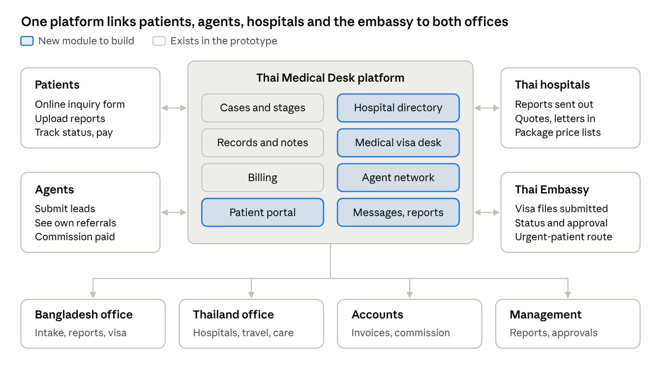
target system · 4 outside parties, 8 modules, 4 internal teams
Patients and agents feed cases in; hospitals and the embassy are worked through structured lists instead of free text; every team sees the same case.

